Are you . . .

Concerned about the ease of use of your products?

Spending too much on documentation, training, operations, or field support?

Bogged down by last minute problems before launching a new product?

In need of an independent evaluation of your user interface or a comparative analysis of alternative designs you are considering?

Having trouble migrating your business processes or products to the web?

We can help . . .
. . . by providing:

Cost-effective user interface design and usability testing --Web, GUI, or mobile applications for government, business. or consumer products.

Well-experienced usability professionals to meet your needs.

State-of-the-art usability facilities and observational data collection tools.

Help in establishing usability engineering programs, facilities or user-centered design processes in your organization.

Our Services:
User Interface Design
- User requirements analysis
- Contextual inquiries
- Focus groups
- Job/task analyses
- Style guide development
- Rapid prototyping
- Interface design

Usability/Accessibility Evaluation
- Usability testing at our place or yours
- Test support in planning, recruiting participants, data acquisition, and/or analysis
- Heuristic reviews (usability audits)
- Accessibility compliance reviews
- On-line surveys
- Field Testing, “Remote” usability testing
- Comparative product evaluations

Organizational Usability Support
- Training seminars/workshops to promote usability engineering in your organization
- Usability professionals for long-term, on-site assignments
- Lab development and installation services

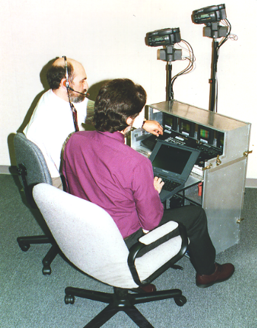
Our Products:
We market, distribute, and provide customer service for the following usability engineering tools by Norm Wilcox Associates, Inc. We offer a practitioner’s perspective to help you determine your product needs.

Lab-in-a-Box – A full-function, portable usability lab in a rugged, shippable container.

Lab-in-a-Bag – A mid-range portable usability lab in a wheeled travel case.

Li’l Lab – A “subcompact” usability lab in a rugged briefcase, for use when extreme portability and low cost are of utmost concern.

(Some of) Our Clients:

Private Sector Government Sector
Accenture Bureau of the Census
AEGON Equity DOD (including Air Force
America Online DAU, Navy)
Ameritrade Dept. of Education
Analytical Sciences Dept. of Labor
Baxter Healthcare FAA
CareerBuilder Health & Human Services
CareFirst (including AHRQ, FDA,
Commerce One HRSA, NCHS)
Euro RSCG Circle IRS
General Electric NASA
Hewlett Packard Nat’l Institutes of Health
IBM (including NCI, NHLBI,
Kodak NIAAA, NIAMS, NIDA)
Lockheed Martin NIST
Manugistics U.S. Dept. of Agriculture
Marriott
Murad Non-Profit Sector
NCS Pearson Amer. Psychol. Assoc.
Nextel Benton Foundation
Northrop Grumman Nat’l Assoc. of Realtors
Ogilvy NASDAQ
SAIC The Nature Conservancy
Sprint PCS The Retired Officer Assoc
Verizon University of Maryland

Our Facilities:

Two instrumented lab suites are available for rent, with or without our services, at our office in the Washington, DC area.

Usability Lab – A 14’ x 13’ User Room for test participants with adjacent Control Room.

Focus Group Room – A 19’ x 14’ Conference Room with adjacent Control Room.

Both suites offer:
- One-way viewing of participants by the Test Team, two-way communications via intercom, space for client onlookers.
- Scan conversion of participant computer screen(s) to NTSC video
- Multi-camera, split-screen video recording
- Audio recording of participant comments with voice-over commentary
- Observational data logging and analysis
- Machine-readable time coding of video tapes and observational logs
- Digital video editing of “highlights” tapes
- LAN, DSL or dial-up modem connectivity

Portable Labs – A Lab-in-a-Box and two Lab-in-a-Bags are available for short-term, on-site rental to clients, with or without our services.

Software Accessibility Testbed – a variety of operating systems, browsers, and assistive technologies for evaluating the accessibility of web sites and other software for use by the disabled.
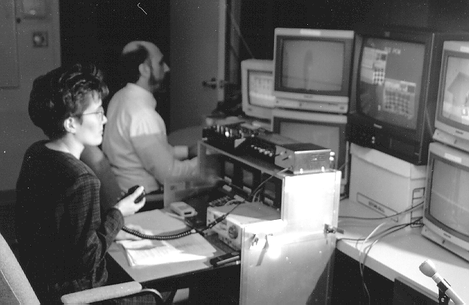
Our Organization:

UserWorks, Inc. was established, as Man-Made Systems Corporation, in 1989. We are a Maryland small business specializing in user interface design, usability engineering and human factors R&D. We have a strong track record of successfully completed projects in service to private sector, government, non-profit, and academic organizations. We will effectively and efficiently address your user interface design problems, no matter how large or small. We strive to be solution providers, not just problem “pointer-outers.” We are conveniently located just one block north of the Washington, DC Beltway in Silver Spring, MD.
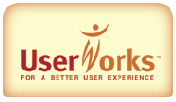

Our People:
We have a well-qualified staff of human factors professionals and a number of prominent consultants who are available to us as needed. Our professional staff members have advanced degrees in such disciplines as human factors, engineering, experimental psychology, computer science, and industrial engineering. We can serve your projects on a consulting basis or by supplying people to work at your site for short- or long-term assignments.
For Usability Engineering:

- Services
- Facilities
- Products

UserWorks, Inc.
1738 Elton Rd, Suite 138
Silver Spring, MD 20903

301-431-0500 (voice)
301-431-4834 (fax)

E-mail address: info@userworks.com
Website: www.userworks.com

Visit us on the Web at:
www.userworks.com

