
AC Services, LLC

Stay with us and experience the difference.

What does AC Services offer to clients?

AC Services offers fully furnished temporary housing. Our services include locating and leasing the finest apartments in selected communities. We provide all the amenities and accessories and manage all the utilities, cable, telephone, long distance and more.

What type of accommodations does
AC Services have?

Our accommodations include 1, 2, and 3 bedroom apartments. All of which are tastefully decorated with premium house wares and furniture. Whether you need a lease for 30 days or 30 months, AC Services will make sure your temporary home is ready when you are!

What types of amenities are provided?

- Large, spacious living areas
- Walk in closets
- Full size kitchen
- Washer and Dryer
- Cable TV and VCR
- Local Phone
- 60 free minutes of long distance
- Full access to club house, business center, and all exercise facilities
- High speed internet (available in most properties)
- Maid service available

What can you expect to pay?
How does the billing work?

Our guest suite apartments are typically less than most hotel rates! Pricing will vary depending on the number of bedrooms, lease term, location, and furniture/accessory package selected. Our packages are designed to fit various budgets. You can choose from economy up to deluxe executive packages. We accept all major credit cards for payment, or direct billing. Payments are due upon move-in and then on the first of each month thereafter.

Need more information? Contact us!

1-800-350-4525
info@acservicesllc.com

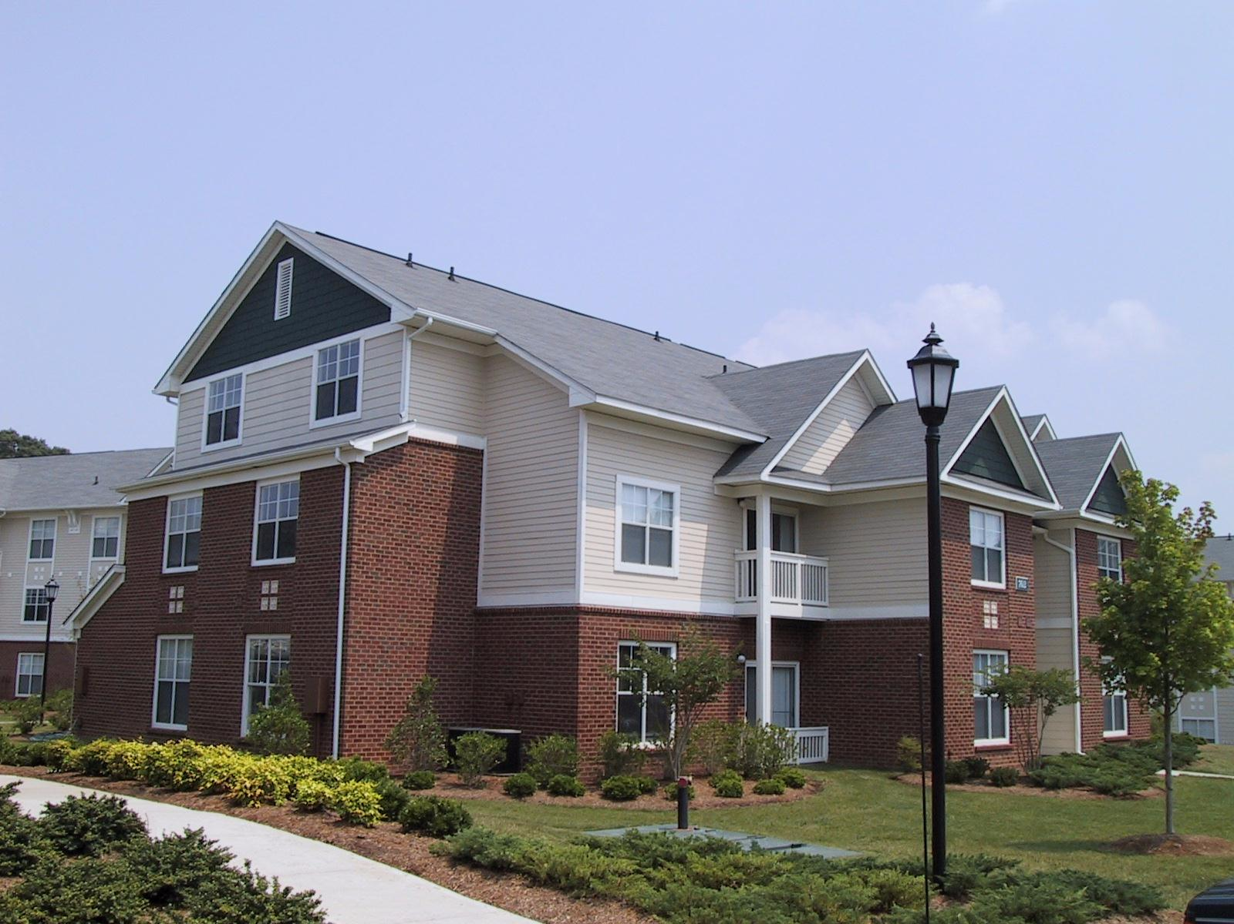
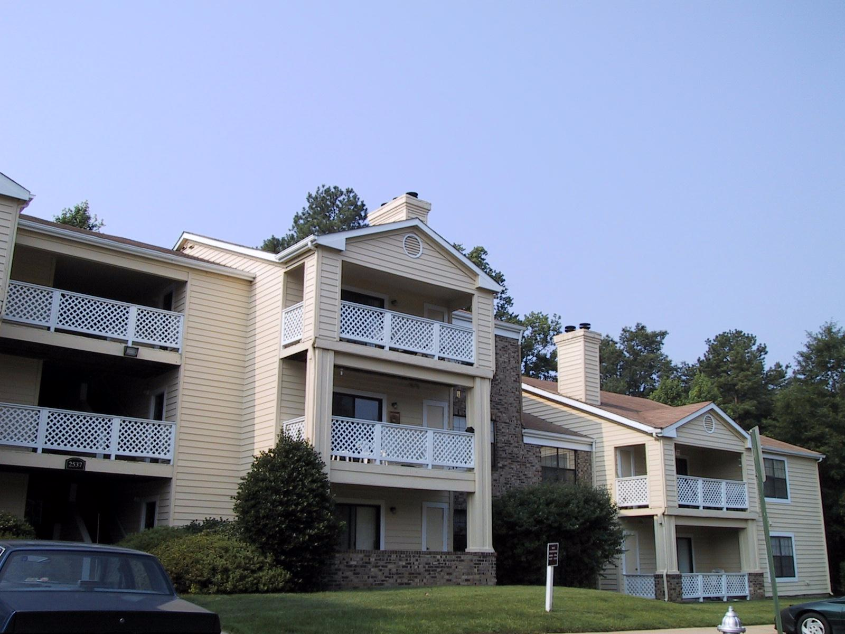
*AC Services is recognized as a certified minority owned business enterprise in the state of Virginia.

