

www.nactech1.com



Company Overview
NACTECH is a Detroit based company with our headquarters located in Detroit. NACTECH has over ten years experience, providing integrated voice, data, video, and fiber optic cable design, wireless networks LAN/WAN, installation and support. We test and certify all installations in strict accordance with manufacturer’s and BICSI standards. We also specialize in Application Development and Web Design.
In addition to providing professional installations at reasonable costs, we are known in the industry as team players that will work seamlessly with the architects, engineers and other contractors in building projects to ensure their overall success.
Our goal is to efficiently provide your business with fast and reliable networking solutions. We can and will assist your company's needs with computerized testing, documentation, and maintenance on voice/data and fiber optic network systems.

NACTECH is a full-service company providing regional and national coverage. NACTECH offers customized solutions and comprehensive programs that we have developed through years of listening to our customers and setting standards that exceed expectations.

Our goal is to provide our customers with one point of contact to solve all of their technology needs. We provide consultative analysis and proactive solutions to keep any issues to a minimum. Our team will work together with your company to formulate a plan that will meet your goals in any of our areas of expertise.

 | Virus Protection  In-house, email, policy and procedures for minimizing attacks. We will look at the current virus protection in place, if any, and determine its effectiveness. We will make recommendations on ways to minimize exposure in this area. Additionally, we will look at the manner in which email is scanned for viruses. We will evaluate your current email provider to determine if they provide the proper first level of virus protection that should be expected at that level. We will look at the current policy and procedure for utilizing the existing or recommended virus programs to maximize their benefit.
 | Infrastructure Analysis  Many offices are not wired properly and therefore lose performance through the use of non-certified cabling. Cat5e standards will be used to evaluate the network performance for reliability. Poor cabling can lead to many "undetectable" problems.
 | Security Analysis and Data Backup  We will examine the method used for backing up server-based information. We will recommend enhancements, if needed, to this process. Additionally, our staff will look at the methods used to back up workstation applications and local data. If inadequate methods are identified, the appropriate recommendations will be included in our report.
Internet Connectivity and Web Site Review
What method is being used to communicate between offices, the Web or the home office? What are the security risks? Can performance be improved and can monthly recurring costs be reduced? Web sites and email services will be evaluated for efficiency. Does the Web site meet the expectations of the customer? If not, what can be done to improve this deficiency?
 | Operating System Analysis  Are the current versions being utilized? Are they patched properly with the latest fixes? If not, recommendations will be made to standardize the office OS platform with the proper version. This can lead to improved performance and reduced downtime.
 | Networking  If the office is part of a wide-area-network (WAN), we will evaluate the communication methods between offices as part of this infrastructure analysis and make the appropriate recommendations.

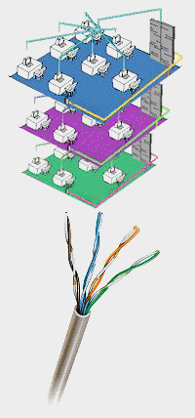
Infrastructure Cabling


NACTECH’s team of cabling experts have experience planning, designing and installing jobs of all sizes, from single-office local area networks (LANs) to national rollouts for Fortune 500 companies.

Low Voltage Communication Wiring
NACTECH provides Project Management, Engineering, Installation and Service for all areas of low voltage communications. We are a standard based company that supports Star, Ring and Bus topologies in accordance with the standards set forth by ANSI, IEEE, EIA/TIA, NEC and ISO. Our Project Managers, Designers, Engineers and Technicians have experience installing the following low voltage cabling systems:

ADC Telecommunications | AMP (NDI)
Avaya Technologies (VAR) | Belden
Berktek | CommScope
Essex | Great Lakes Cabinets
Hammond Cabinets | Hitachi
Homaco | Hubbell
Interlink Technologies | Leviton (Certified)
Mohawk (Certified) | Nordx/CDT
Optical Cable Corporation (OCC) | Ortronics (Certified)
Raychem Closures | Reltec
Rittal Cabinets | Siecor
Siemon Certified Installer | X-Mark Cabinets
3M Telecom Products

Experienced Project Managers

Our Project Managers follow a strict methodology on installation, reporting and acceptance testing procedures. Upon completion, we will provide you with a written certification of inspection and testing guaranteeing that the job was done right.

We will provide a dedicated Project Manager to your account that will be able to answer any questions you have in a timely manner.

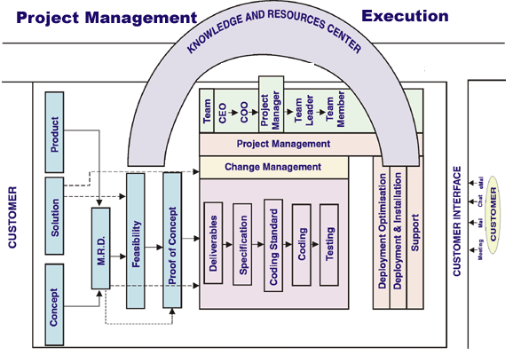

Our teams are industry experts delivering first class solutions in the following areas:

- Infrastructure Cabling
- Network Integration
- Application Development

WE SPECIALIZE IN THE FOLLOWING:
Data Communications | Fiber Optic Networks
Web Design | Application Development
Voice Communications | Card Access System
Video (Broadband) | Wireless Networks
Closed Circuit Television | Microwave Networks
Paging Systems | Fire Alarm Systems
Nurse Call Systems

CABLING SERVICES | OUR ABILITIES | CABLING CAPABILITIES
 | 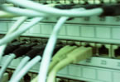 | 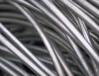
Horizontal, Backbone, and Campus Cabling for Voice and Data | Benefits of Proper Cabling: | Network Design/Certification services
CAT5e, CAT5E, & CAT6 Cabling | Clean up exposed wires | CAD department and archiving
Installation and Certification | Eliminate computer headaches that may be caused by bad cabling | Physical site audits and inventory
Fiber Optic Cabling | Labels for quick identification | Project Management (on-site and off-site)
Single or Multi Mode | Labels for quick identification | Cabling Design
OTDR Rental | Labels for quick identification | Certification Testing
Fiber Testing | Labels for quick identification | Facilities Review
Fusion & Mechanical Fiber Splicing | Labels for quick identification | Diagnostics and Troubleshooting
Specialized hybrid cabling for electricity and data | Labels for quick identification | Complete Documentation
Cabling for CCTV Camera systems | Labels for quick identification

LAN/WAN

We are experts in setting up and supporting Local Area and Wide Area Networks, including:

Microsoft Windows NT/2000
Novell Netware
IBMAS/400
Citrix Metaframe
Exchange 5.5/2000
GroupWise
- Cisco Routers/Switches

Security

Your corporate information and your systems must be protected. NACTECH'S will design a solution that fits your organization using the latest in security and firewall technologies:

Check Point
Cisco PIX
Sonicwall

Preventive Maintenance

We will make the most out of your investment. NACTECH will keep your systems up-to-date and optimized, for the best performance preventing costly downtime. Including:

Virus Updates
User Support
Backup Job Monitoring and Scheduling
Error Log Monitoring
Event Monitoring
Application Development

We are more than just a vendor, NACTECH works as your partner to make sure the job is done right. As a Microsoft Certified Partner NACTECH specializes in project-based application development. That means from the initial concept to going live we will make your systems work at optimum levels.

Technologies

NACTECH has extensive experience building custom solutions across a full spectrum of platforms, including:

Client/Server | Kiosk | Extranet
Internet | Intranet | Mobile Computing

We use technologies you trust, including:

- Visual Basic | BizTalk
- SQL-Server | ASP
- XML | JAVA
- SOAP | JSP
- Oracle

EXPERIENCE

Universal Medical Standard Laboratories | Wayne County
K-Mart Corporation | Federal Court
Detroit Medical Center | Wayne State University
Electronic Data Systems (EDS) | Beaumont Hospital
Ameritech | St. John Hospital
Chrysler | University of Michigan
IBM | City of Detroit

Lifecycle Management

Lifecycle Projects
- Technology Solution Design/Planning
- Technology Refresh
- Hardware Installations/LAN Integration
- Software/Image Distribution & Upgrades
- Server Upgrades

Staff Supplementation
- Different skill sets per requirements
- You concentrate on core business
- Contract only for what you need
- Dedicated for 1 week -12 months

Help Desk
- Customized solutions
- Trained & Certified Support Specialists
- Call tracking & reporting
- Quality assurance monitoring

Configurations & Upgrades
- Systems set-up & integration
- Operating system and software loads
- Desktop & server upgrades
- Peripheral installation & configuration

Asset Management
- Asset Tracking/Control
- Bar-coding
- Redeployment
- Disposal

Electronic Procurement
- Internet ordering with real-time access to 45,000 items and $4.5 billion in inventory
- Corporate standards are identified and used to create MasterPacks
- Authorized access security
- Order Management

Technical Services

Warranty Service
- Warranty Authorized by the major equipment manufacturers
- 6,000 certifications earned by over
400 NACTECH
technicians

Equipment Maintenance & Repair
- Mission Critical server maintenance
- Part-in-hand response
- Printer maintenance & repair
- Certified technicians
- On-site spares/swaps
- On-site dedicated technicians
- Block Time Agreements
- Depot services
- Authorized warranty service/repair

Priority Laptop Services
- 24-48 hour repair at our facility
- Pre-configured hot spare
- Hot spare shipped if not repairable in predetermined time frame

Network Expansion & Security
- LAN/WAN planning & design
- Network integration
- Server Management Applications
- Network Security Audits
- Firewall Applications
- DOS & NOS Migrations
- E-mail and messaging
- High availability solutions

Nationwide Services
- National resources & partners
- Single Point of Contact
- Scheduled maintenance to 7x24 emergency service

Enterprise Solutions

Project Management
- Assist with planning & implementation
- Single Point Of Contact
- Manage third party vendors
- IMAC: installs, moves, adds, and changes
- Multiple levels of expertise

NAS/SAN Design & Installation
- Planning and design
- Product evaluations
- StorageWorks / EMC
- Heterogeneous environments
- Data migration services

Disaster Recovery Solutions
- Evaluation and planning
- Data protection and restore
- CommVault Galaxy
- Off-site storage services


Right People…
Right Time…
Right Answers…

Right People…
Right Time…
Right Answers…

AFFILIATIONS
Our management staff is actively affiliated with:


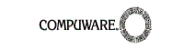


- Construction Association of Michigan (CAM)
- National Electrical Contractors Association (NECA)
- Building Industry Consulting Service International (BICSI)

We have BICSI certified RCDD and LAN Specialists to assist you with the design and implementation of your network.
Our installation and technical staffs are affiliated with the International Brotherhood of Electrical Workers (IBEW).
All design drawings are completed using the latest version of AUTO-CAD.

EMERGENCY SERVICE
NACTECH offers a fleet of well-equipped service vehicles, for 24 hour on-call service. Our standard on-call policy is as follows: During normal business hours, four (4) hour on-site response for customers that have extended service plans. After hours, weekends and holidays, a technician will respond to the service call within one (1) hour and if required, be on-site within eight (8) hours.

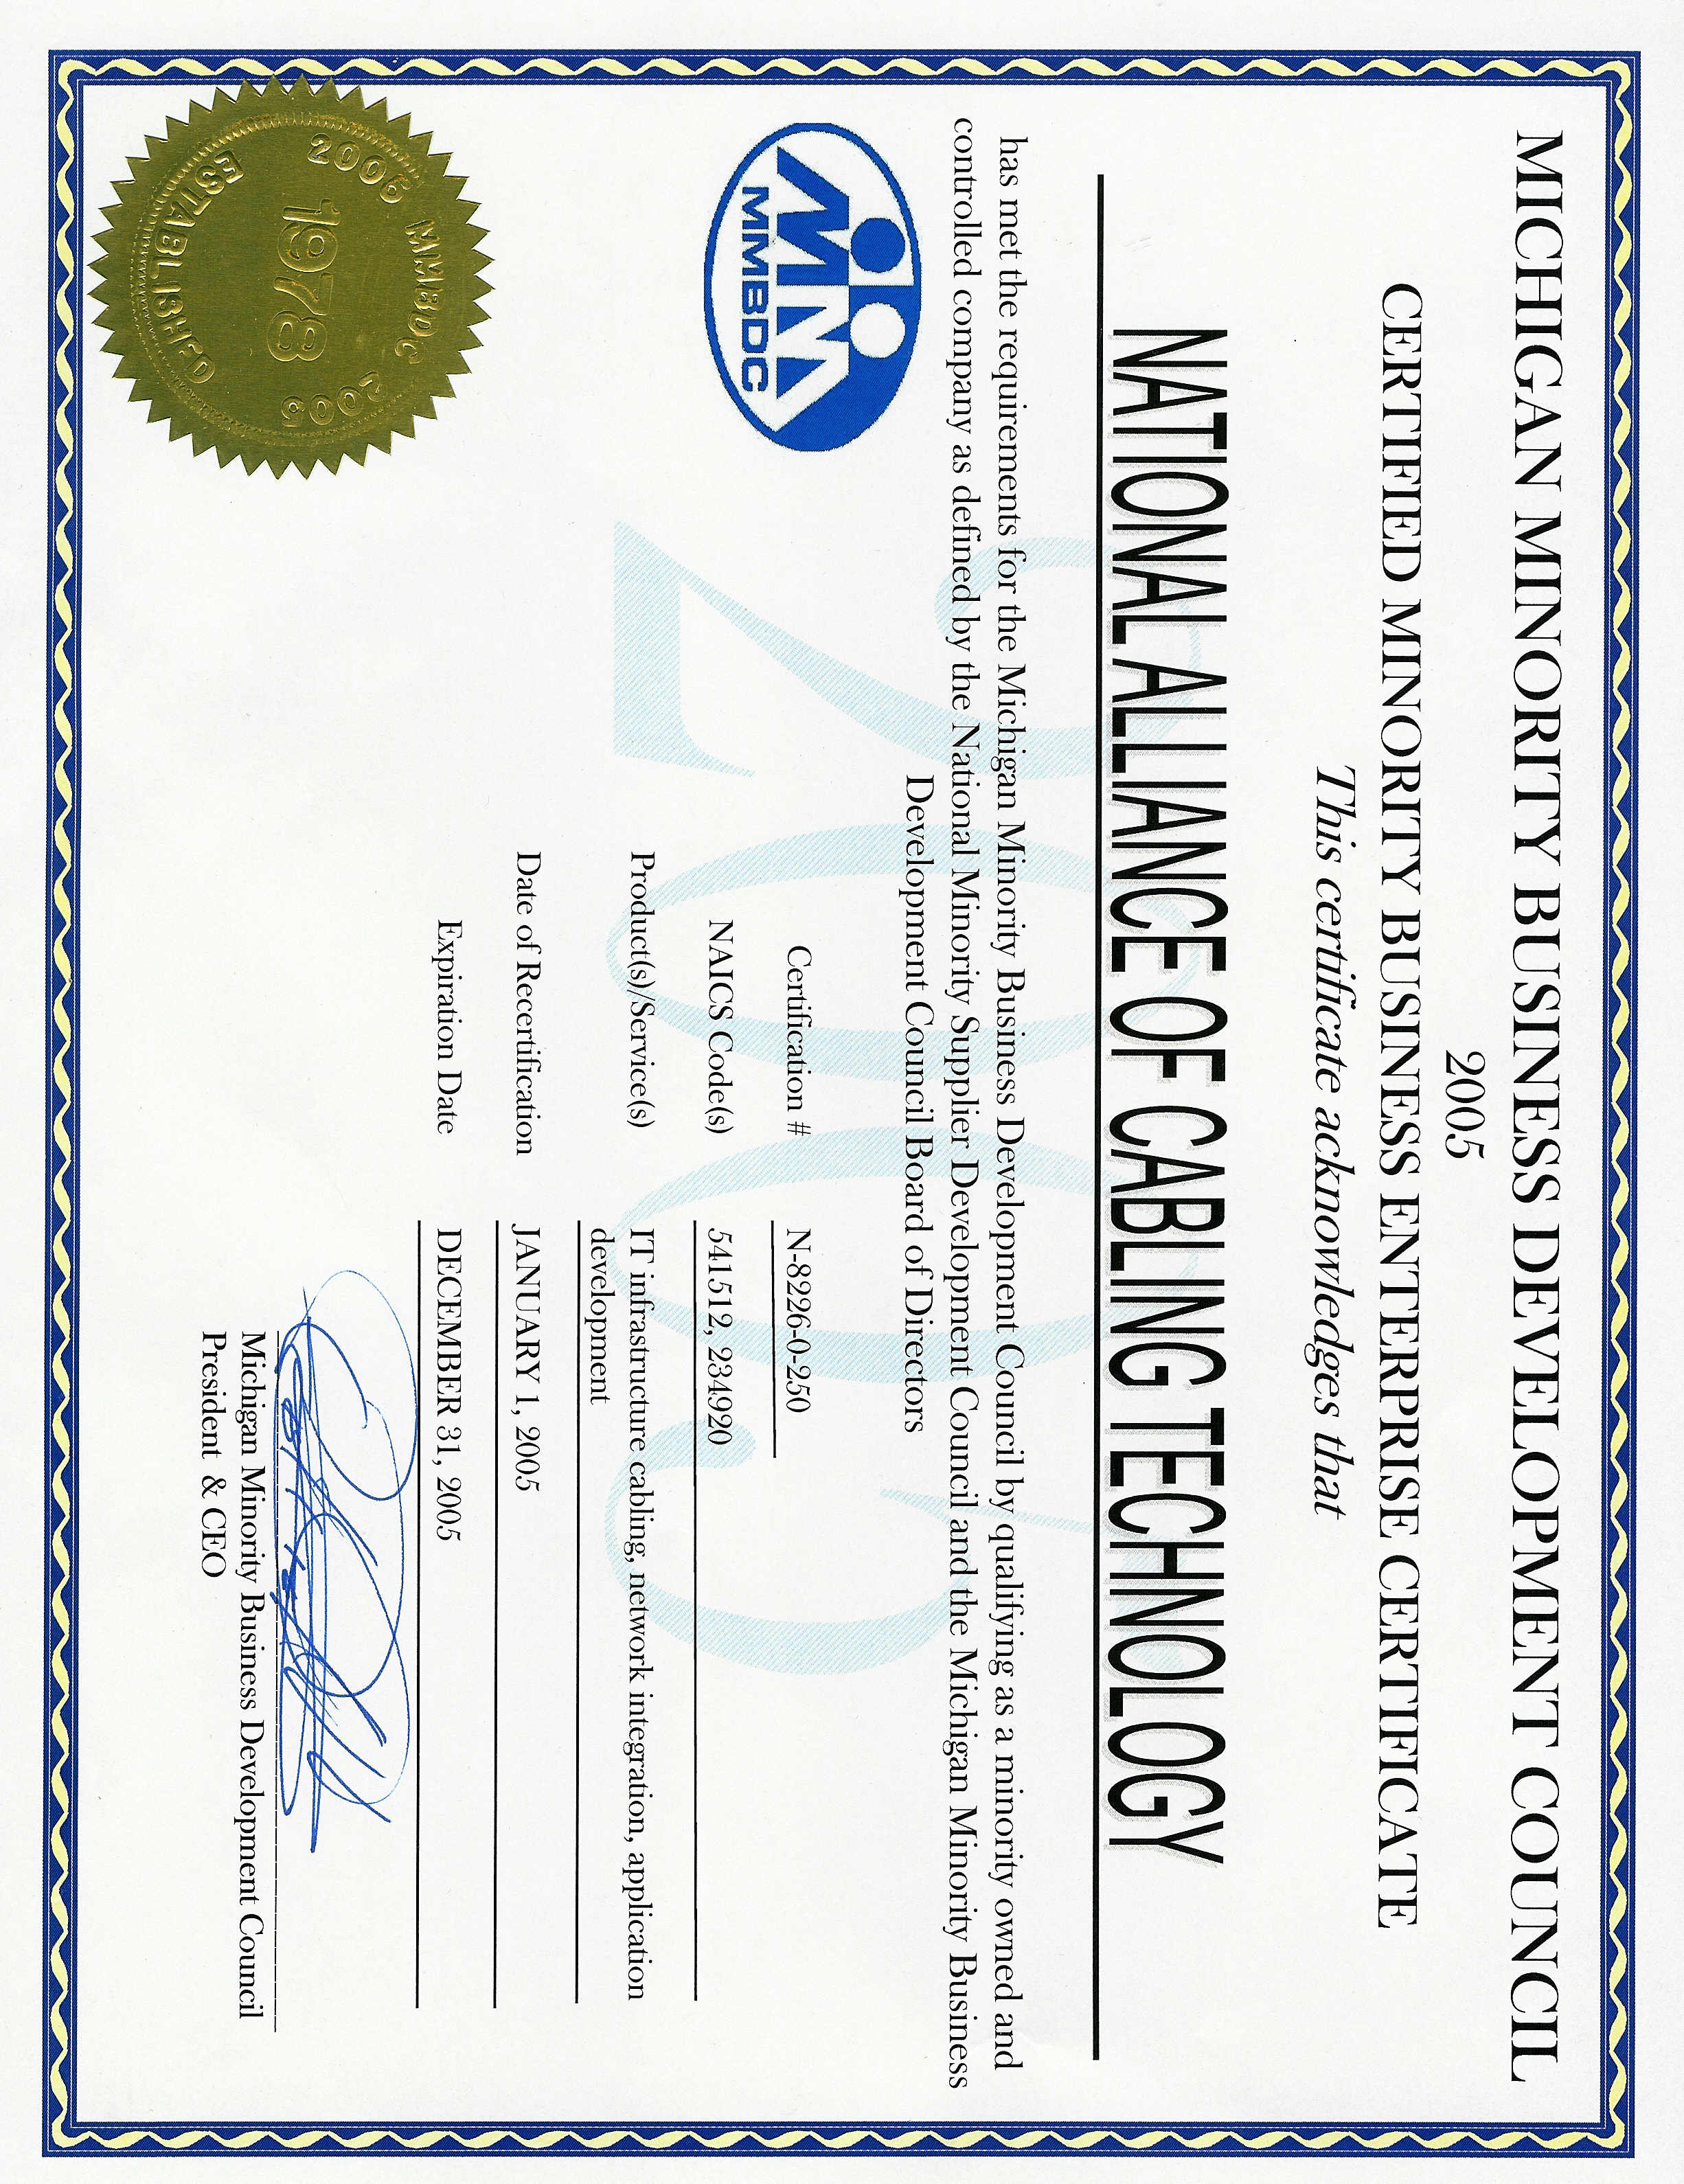

LIFETIME LABOR WARRANTY
NACTECH provides a lifetime warranty on all workmanship. We warrant all electronics for a period of ninety (90) days or the manufacturer’s warranty, whichever is greater.

CORPORATE PROFILE

Nathan Crymes  President/CEO  Office: 313-965-0935 ext. 104 | Kimberly L. Hasting  Vice President  Office: 313-965-0935 ext. 102
Tom Mirowski Carleton Johnson
Field and Service Manager Chief Information Officer
Office: 313-965-0935 Office: 313-965-0935

Matt Montgomery Neal Krantz
Chief Financial Officer Fire & Security
Office: 313-965-0935 ext. 103 Office: 313-965-0935



www. nactech1.com

